Dataset: Energy_Consumption_Data.csv
Sector | Region | Month | Temperature (°C) | Units_Consumed (kWh) | Cost (₹) | Renewable_Usage (%) | Peak_Hours
Residential | North | Jan | 15 | 320 | 2100 | 22 | 4
Commercial | South | Jan | 24 | 540 | 3600 | 18 | 6
Industrial | West | Feb | 20 | 880 | 5900 | 12 | 8
Residential | East | Feb | 18 | 350 | 2300 | 25 | 5
Commercial | North | Mar | 28 | 610 | 4100 | 20 | 7
Industrial | South | Mar | 30 | 920 | 6200 | 15 | 9
- Import the dataset in R. Plot a histogram and density plot for Units_Consumed. Compare consumption patterns.
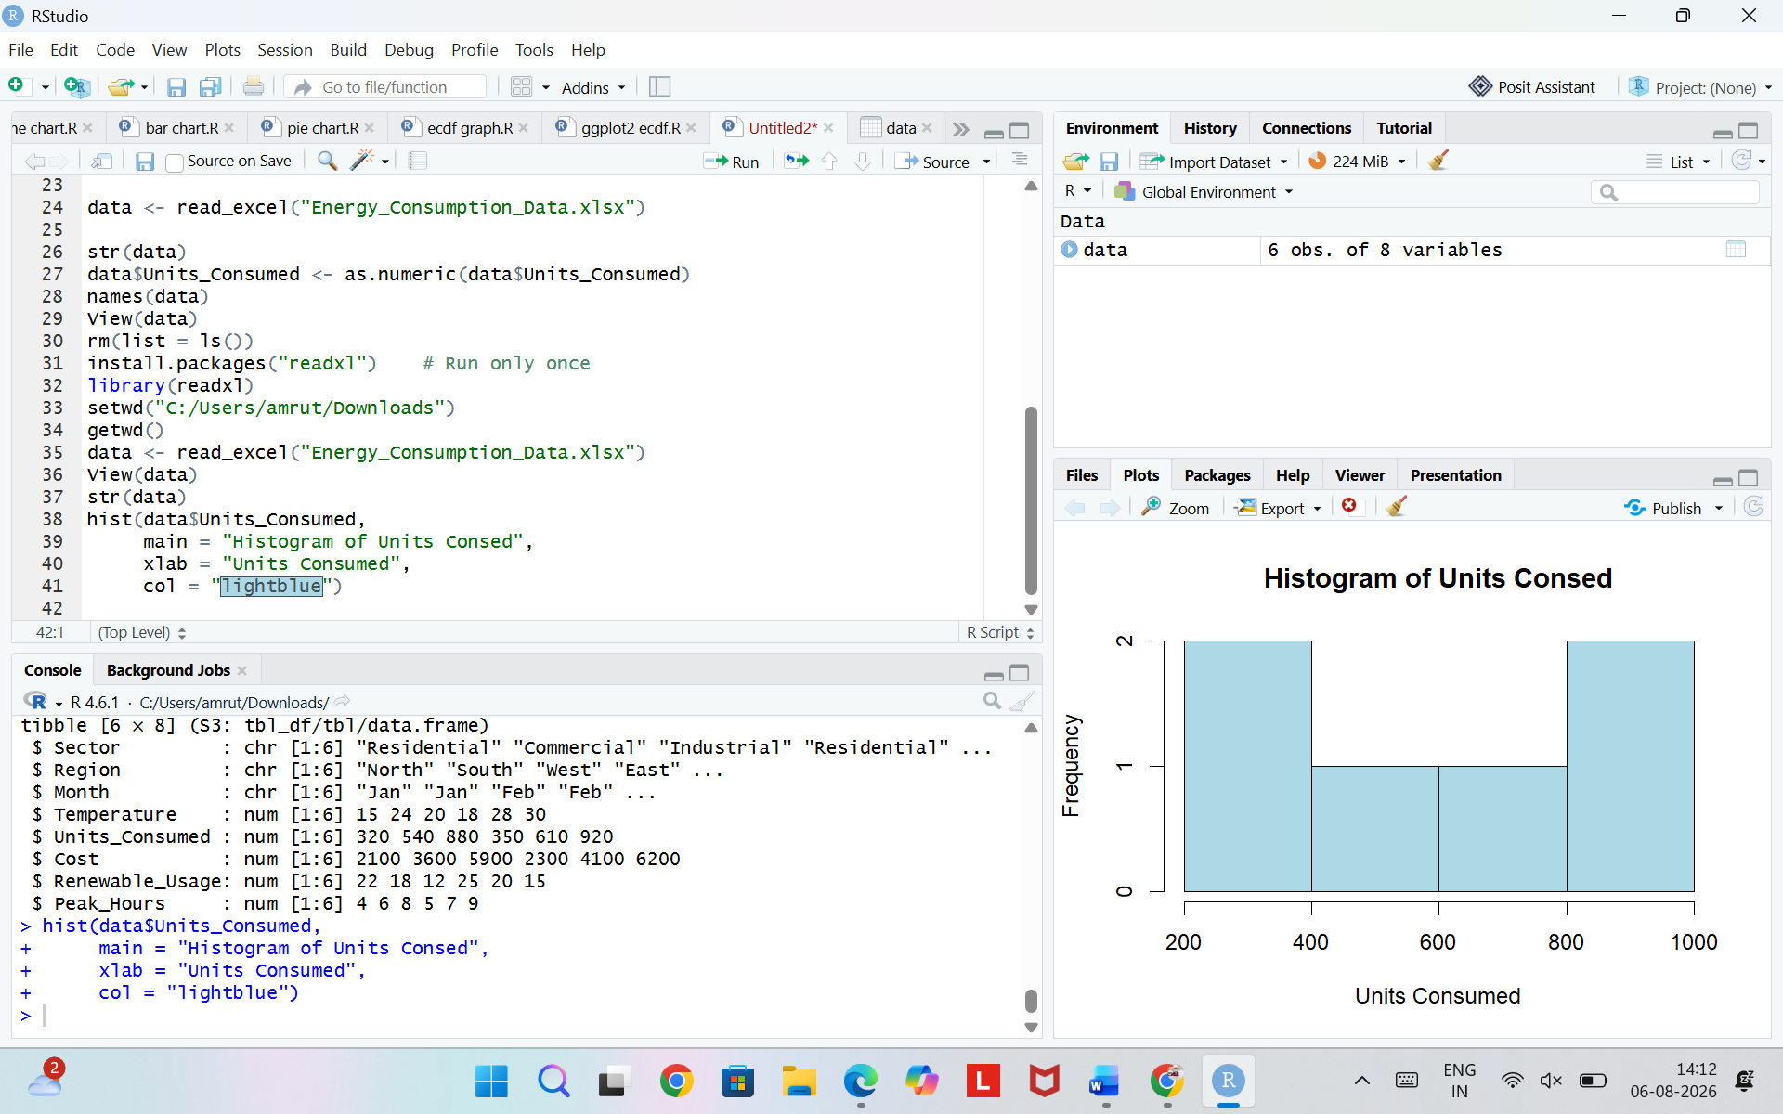
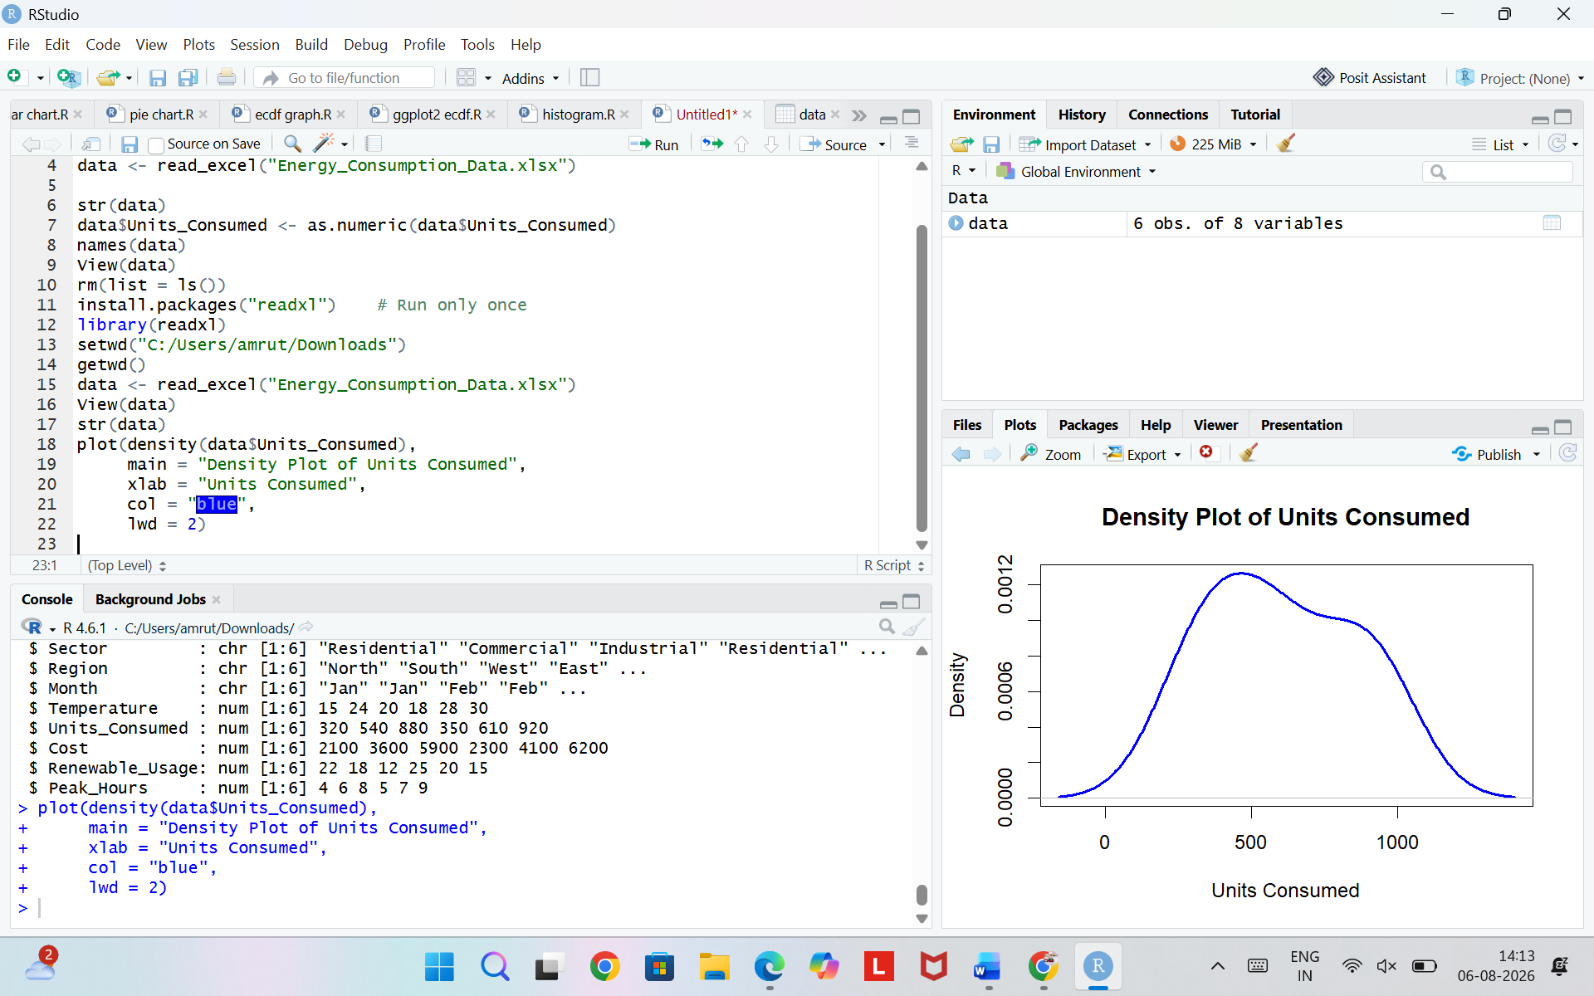
- Using R programming, create a scatter plot between Temperature and Units_Consumed. Represent Peak_Hours using bubble size. Apply transparency.
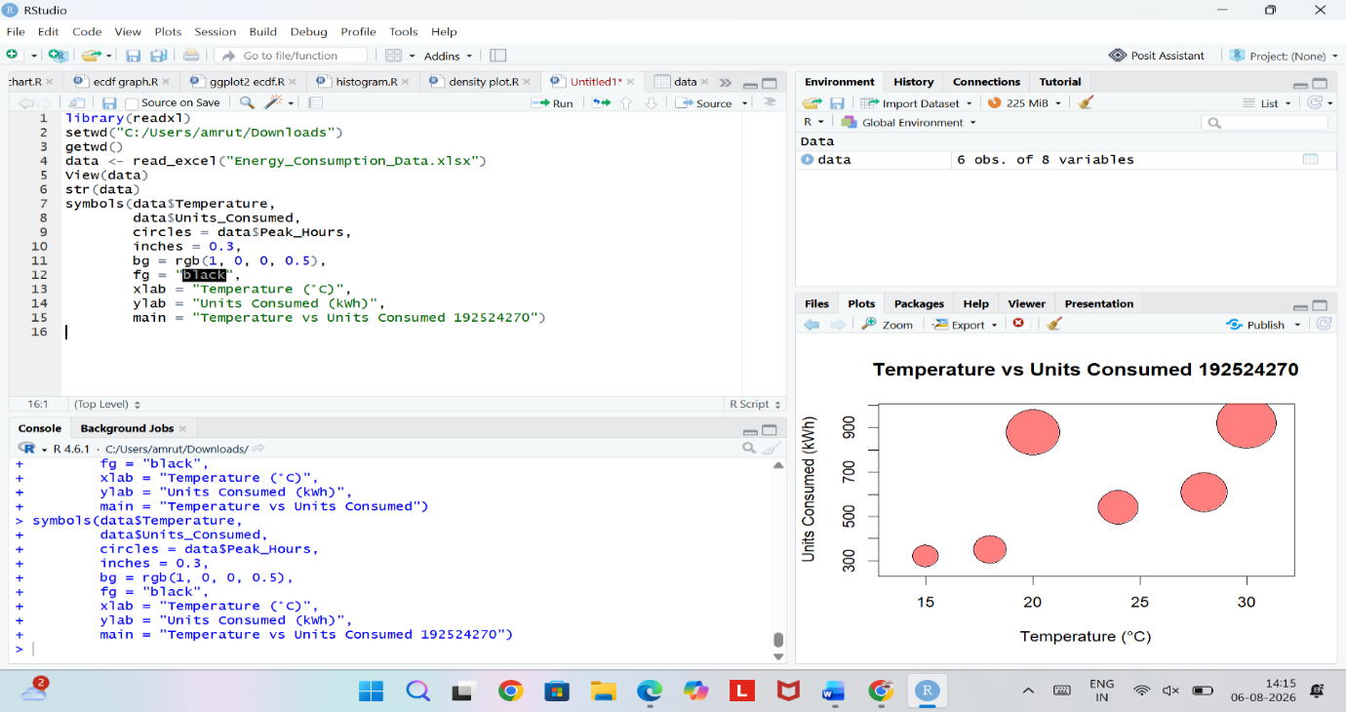
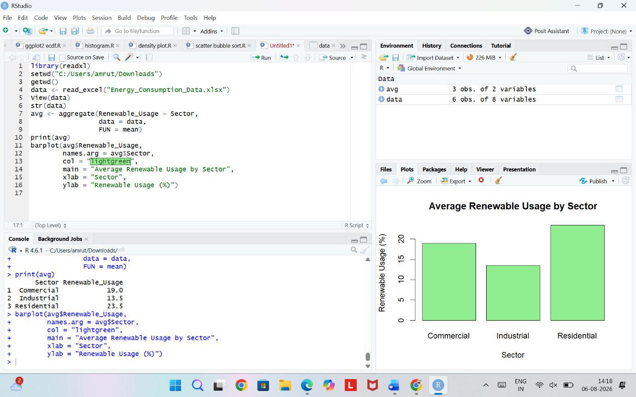
- Using R, calculate average Renewable_Usage for each Sector. Create a bar chart. Interpret renewable energy adoption.

- Import Energy_Consumption_Data.csv into Tableau. Create a line chart for monthly energy usage trends. Create a heatmap (Sector vs Region vs Units). Add filters for Month and Sector. Design an interactive dashboard.
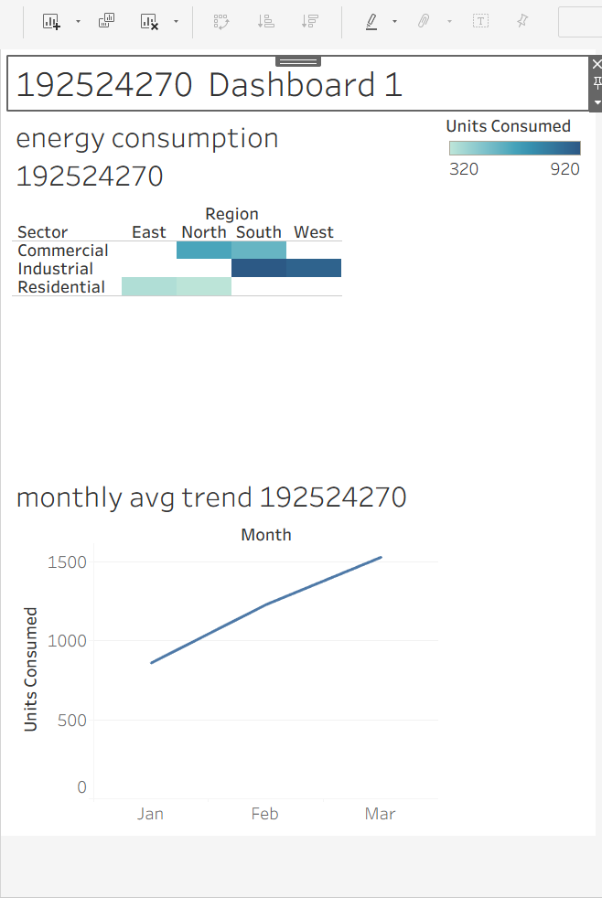

SET 15– Student Mini Data Analysis
Dataset: Student_Mini_Data.csv
Student_ID | Gender | Study_Hours | Attendance | Math_Score | Science_Score | Exam_Date
S01 | Male | 2.0 | 78 | 62 | 65 | 2025-01-10
S02 | Female | 3.5 | 90 | 80 | 85 | 2025-01-10
S03 | Male | 1.5 | 70 | 55 | 58 | 2025-02-12
S04 | Female | 4.0 | 95 | 90 | 92 | 2025-02-12
S05 | Male | 2.8 | 85 | 72 | 74 | 2025-03-15
S06 | Female | 3.0 | 92 | 82 | 86 | 2025-03-15

Questions
- Import the dataset in R. Plot a histogram for Math_Score. Draw a boxplot of Science_Score by Gender. Add proper title and labels. Interpret the results.
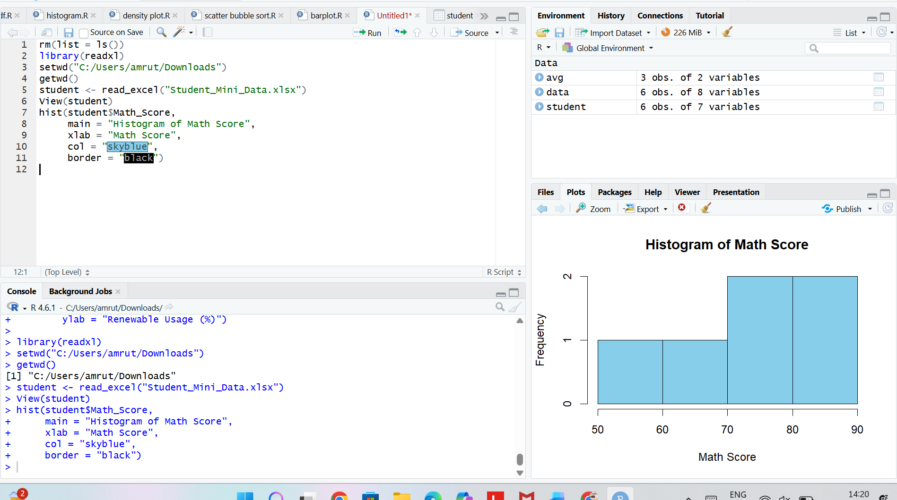

- Create a scatter plot using R programming between Study_Hours and Math_Score. Use different colors for Gender. Add a regression line. Explain the relationship between study time and performance.

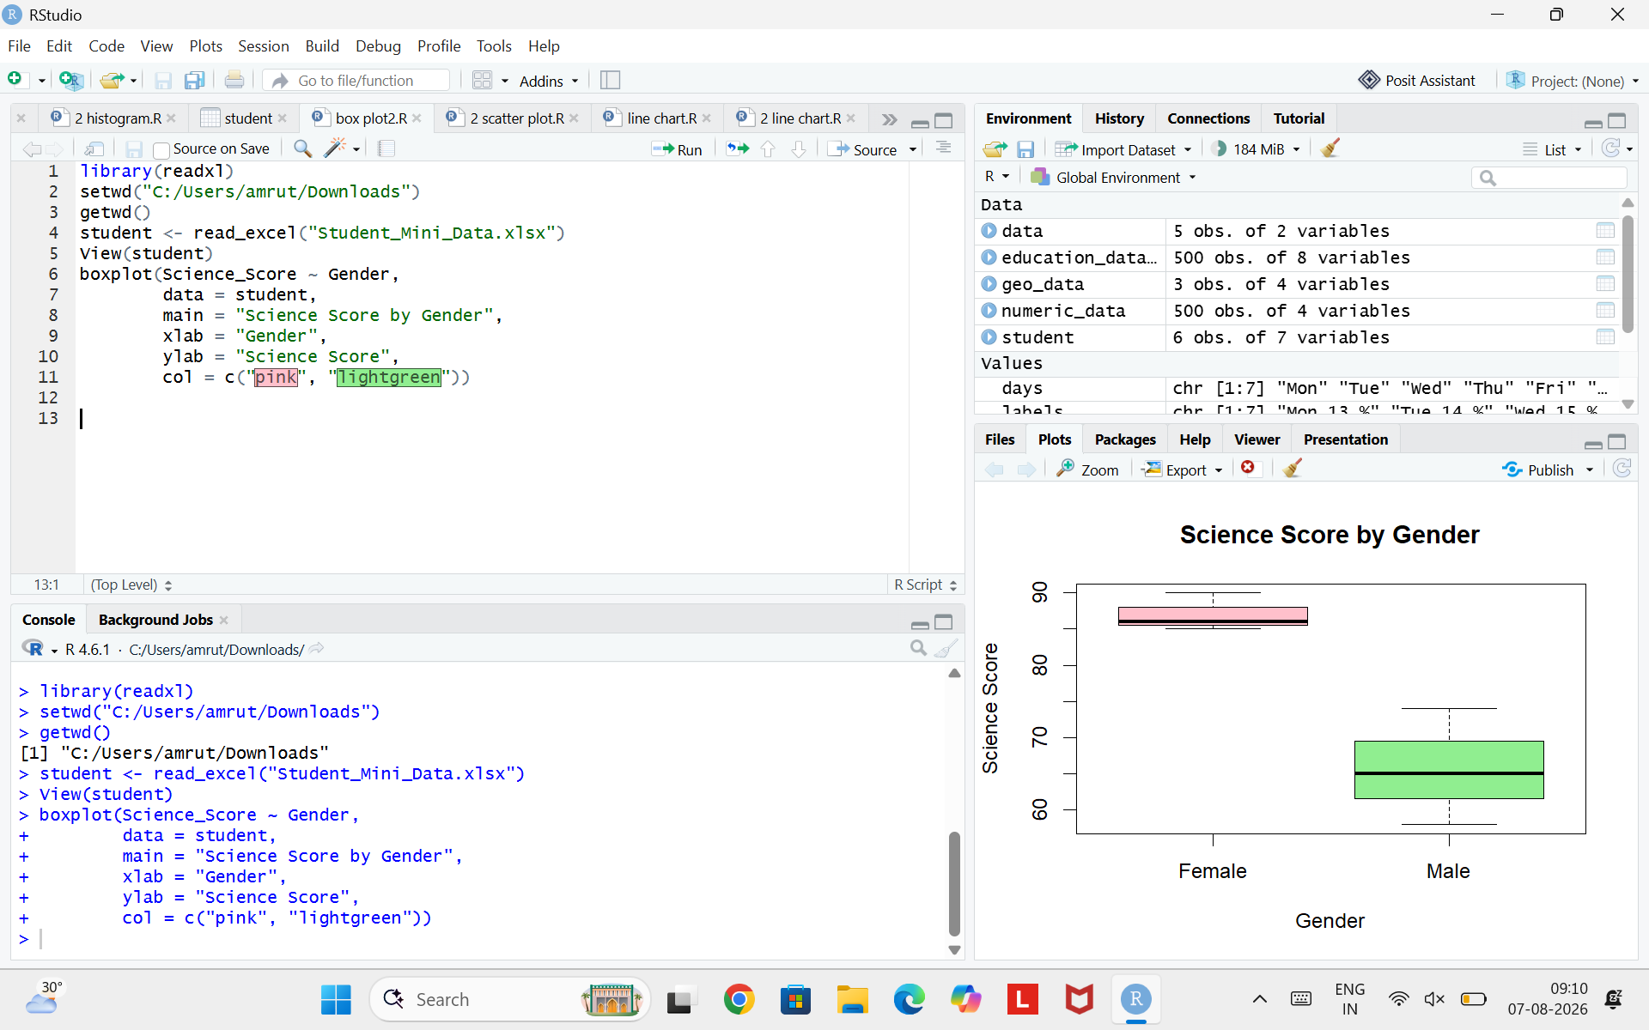
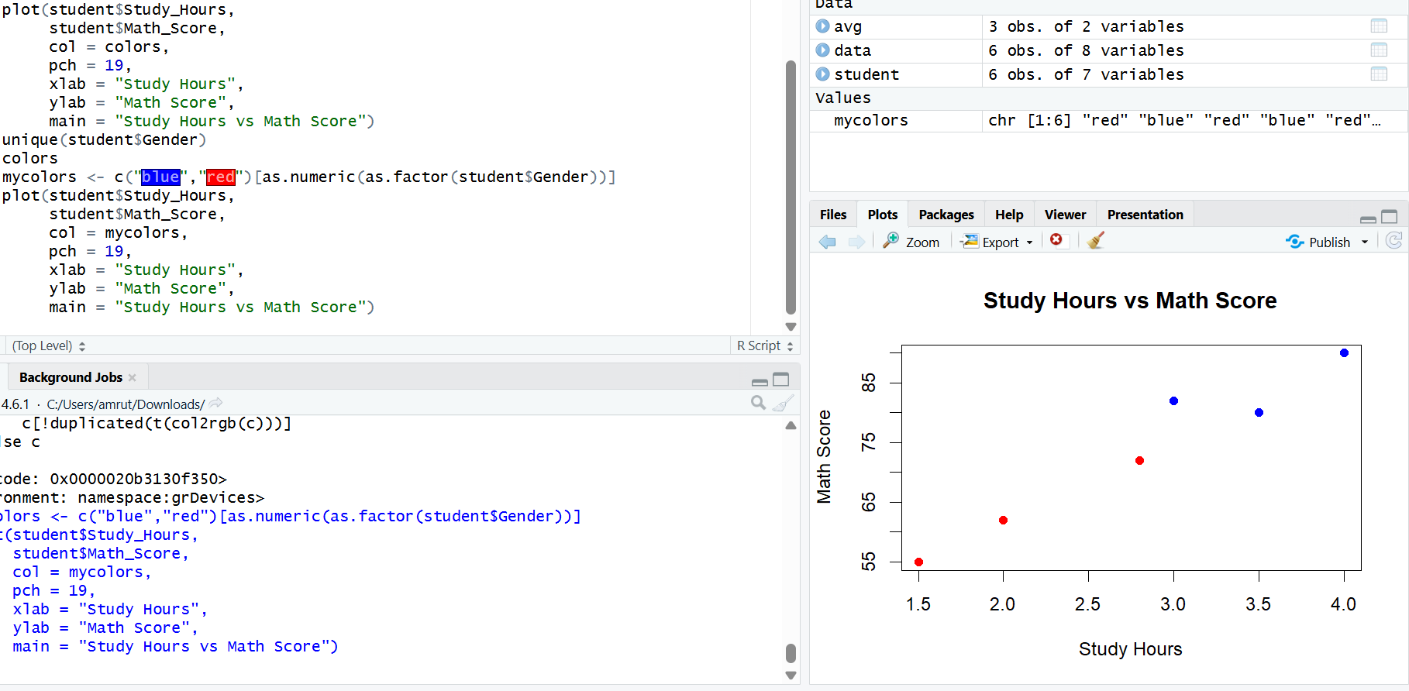

- Using R, convert Exam_Date into Date format. Calculate monthly average Math scores. Plot a line chart for the trend. Apply moving average smoothing. Identify any increasing or decreasing pattern.
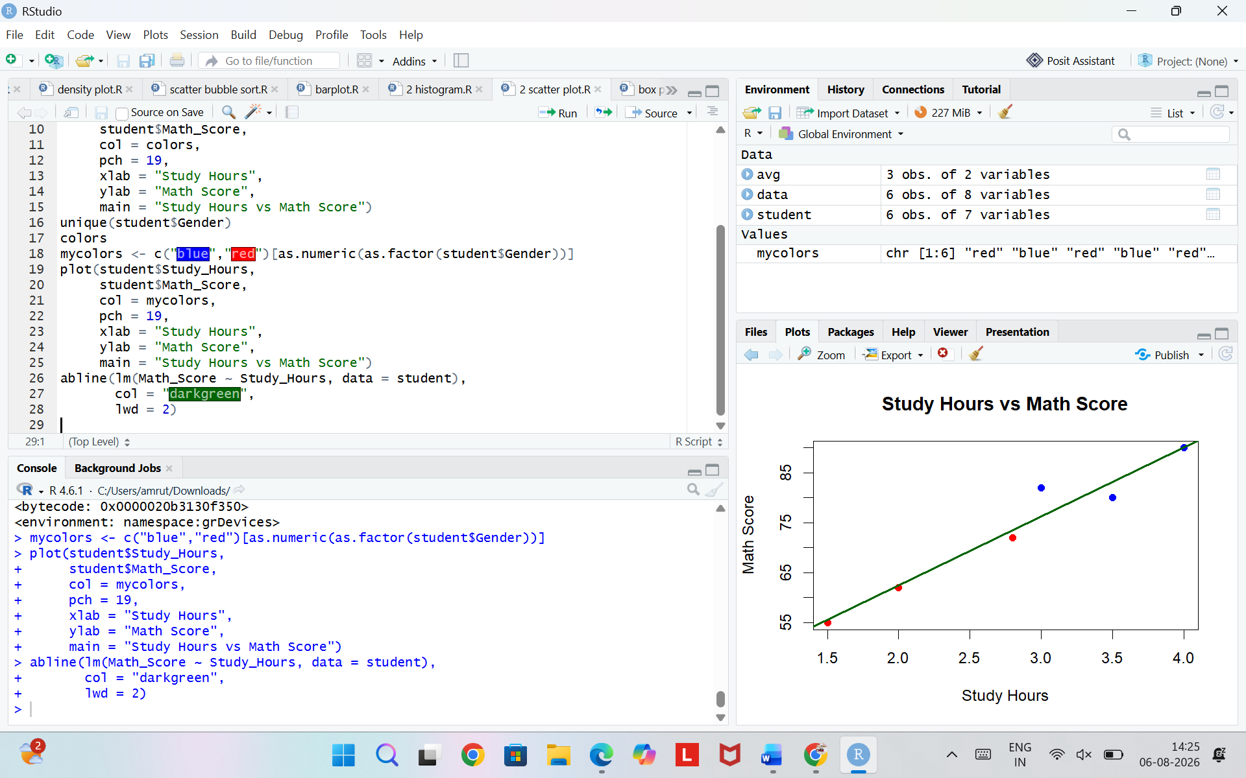

- Import Student_Mini_Data.csv into Tableau. Create a bar chart showing average Math scores by Gender. Create a line chart for score trends over time. Add a filter for Exam_Date. Design a simple interactive dashboard.
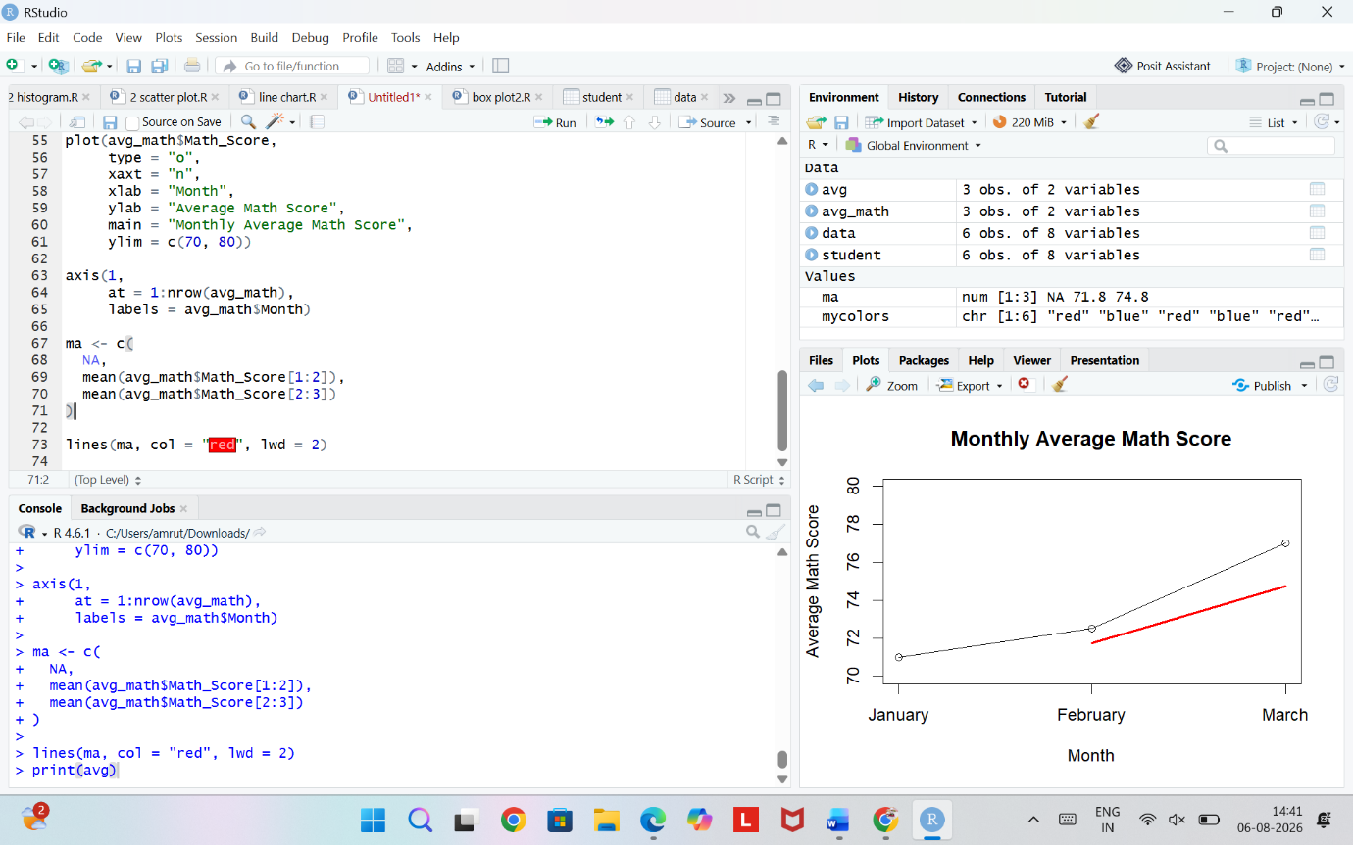

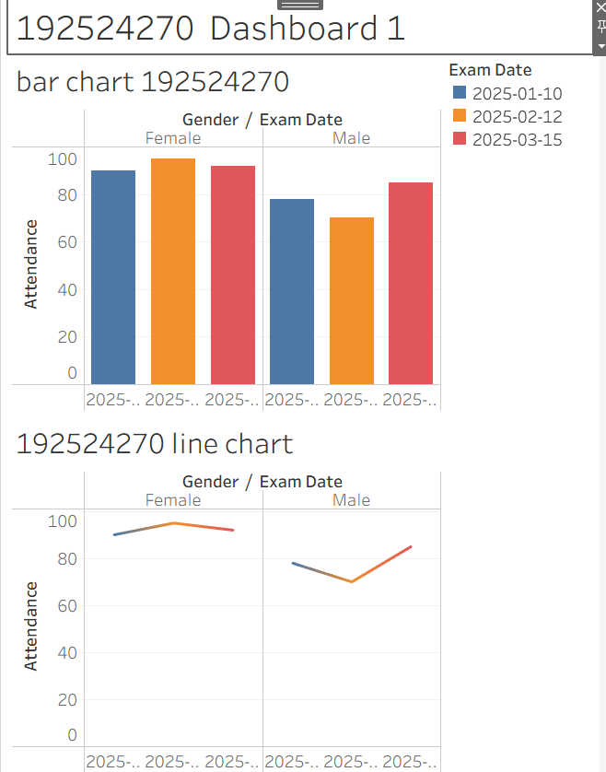

ECDF GRAPH:
